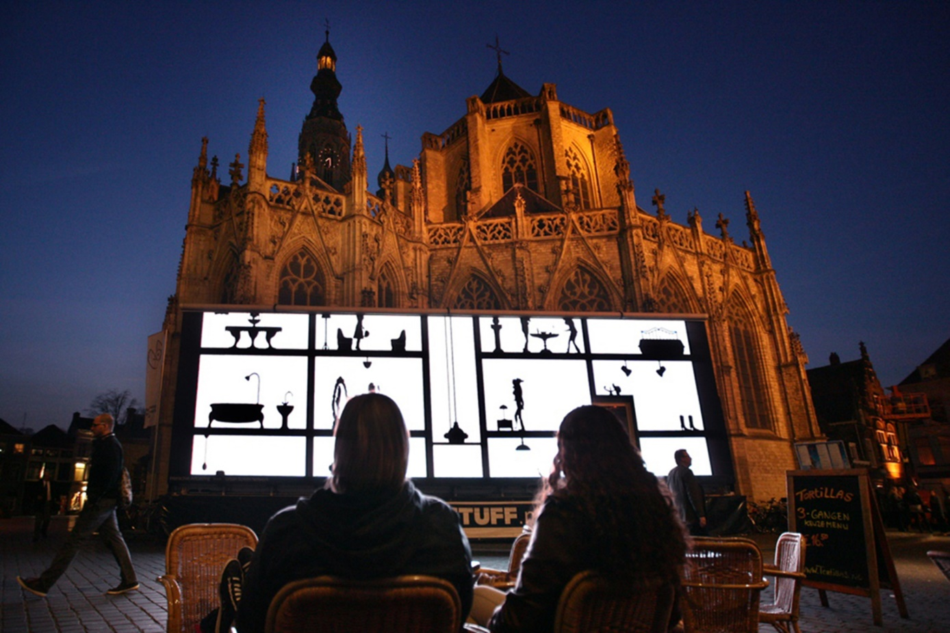
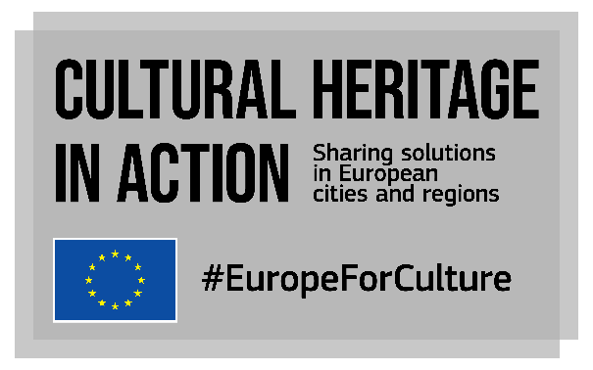
CALL FOR PARTICIPANTS IN onsite PEER LEARNING VISITS
Opening date: 1st March 2022 - Closing date: 25 March 2022

What is ‘Cultural Heritage in Action’?
Cultural Heritage in Action is one of the actions of the European Framework for Action on Cultural Heritage of the European Commission. Started in 2020, it is a peer-learning programme that already allowed over 100 local and regional policymakers to exchange knowledge on cultural heritage, with a focus on participatory governance, adaptive reuse of heritage buildings and quality of interventions.
In its second phase (2021-2023), the project will continue to empower cities and regions to strengthen their cultural heritage policies and initiatives as well as develop innovative solutions to preserve cultural heritage assets.
Our consortium led by Eurocities with KEA, ERRIN, Europa Nostra and Architects’ Council of Europe leads the project funded by the European Union’s Creative Europe programme until January 2023.

What will happen until January 2023?
We have produced a catalogue of 32 good practices from EU cities, regions, urban, non-urban and rural areas, organised 10 online peer-learning visits bringing together 20+ participants per visit and produced 39 videos presenting practices from online host cities and regions.
Until January 2023, we will enrich our catalogue with 30 more good practices from EU cities, regions, urban, non-urban and rural areas and organise a set of peer-learning activities, including 5 onsite peer learning visits. We are confident we can organise onsite visits now, paying attention to the sanitary regulations in place and keeping an eye on the sanitary situation throughout Europe.
We are now organising 5 peer learning visits for European cities and regions’ representatives.
What are peer-learning visits? Peer-learning visits are part of the catalogue of peer learning activities offered by Cultural Heritage in Action and will take place onsite.
Visits are an opportunity for experts, decision makers and stakeholders to visit another city/region and see first-hand how it has successfully implemented policies and projects. Visits will be organised by host cities/regions in cooperation with members of the consortium implementing Cultural Heritage in Action. About 25 participants, who will be selected through calls for interest in 2022, will be able to attend each visit. Cultural Heritage in Action’s peer learning visits will take place between May and November 2022 and will be organised by the project, hosts cities/regions and dedicated experts.
To continue the peer-learning experience after the visit, a number of online activities will be organised with the hosts, participants and dedicated experts:
- An online deep-diving session: an online follow-up workshop to replicate local example(s), one month after the onsite visit. Short (max. 2.5h), open to the group of selected participants and external stakeholders (and potentially to other interested participants) with the involvement of experts who attended the onsite visit. The objective is to come back to one specific practice presented during the onsite visit and discuss more in-depth its transferability aspects. Participants come back on the lessons learnt from the visit and expose them to external participants.
- An online monitoring session: a 1-hour workshop to follow up on transferability and replication of practices in the participants’ cities/ regions. Open to the same group of participants who took part in the onsite visit, moderated by experts. The session is based on participants’ feedback reports and follows up on their implementation plans after their visit to the host city/region.
I want to participate in a visit, is this call for me?
If you work on culture and cultural heritage for a local, regional or national administration, civil society organisation, cultural initiative or project in the EU 27 + UK then this opportunity was made for you! The group of selected participants will be composed of representatives from European cities and regions but is also open to a limited number of cultural heritage stakeholders.
Visiting one of five host cities/regions, you’ll discuss their successful local policies and projects, top tips, pitfalls and failures, as well as your own local experience, in a private and friendly expert environment. Selected participants will get useful information and ideas for improving or initiating local projects or transferring some of the presented practices.
If you have any doubt, please contact us at culturalheritageinaction@eurocities.eu
How will the participants be selected?
The following criteria will be considered in the selection:
- Overall quality of the application
- Motivation to participate in a specific peer learning visit: improve a specific practice or project, implement a new practice or project…
- Matchmaking between the theme of the visit and the need of the applicants
- Commitment to take part in the visit and commitment to allocate sufficient time to preparation and follow-up
- Balance of the delegation: political/technical/decision-making level, broader mandate than culture
Selected visitors will be informed of the results by Eurocities by the beginning of April.

What is the format of a peer-learning visit?
Each visit will last 2.5 days and 2 nights and will combine meetings with local policymakers and stakeholders, site visits and solution-building workshops. The working language will be English.

What does participating in a visit mean for my city/region? What will I be expected to do?
During the visits:
- You will be introduced to the host city/region local context and successful practices related to culture and cultural heritage. You will get useful information and ideas for improving your existing local projects, initiating new ones or transferring some key elements of the presented practices.
- Our peer learning methodology is designed to stimulate interaction, collaborative learning and solution-building! You are expected to ask a lot of questions.
- To prepare the visit, each participant in each peer learning visit will receive a participants’ pack 10 days before the visit.
- After the visit, you will be invited to fill in an evaluation form and attend 2 online follow up workshops. The workshops aim to work on transferability aspects between what you have seen and discussed with the host and your own local context: how can the lessons learnt be applied in your own city or region?

What are the costs for my city/region/employer?
The Cultural Heritage in Action project will cover travel and accommodation costs for participants, as well as lunches and dinners (our consortium will take care of all logistical aspects). If selected, you will be contacted by our event’s team to coordinate logistical aspects.
Please be aware that due to the sanitary situation in Europe, participants need to ensure that they meet all regulations in place at the date of the visit to travel to and enter the host country. Cultural Heritage in Action is not in a position to guarantee reimbursements of participants’ travel costs if they cannot travel because of sanitary regulations.

Application form for the peer learning visit hosted by Leeds, united kingdom
Please write in a clear and concise manner, keeping in mind that the reader is not familiar with your local context. Should your application be selected, we will come back to you for additional information.
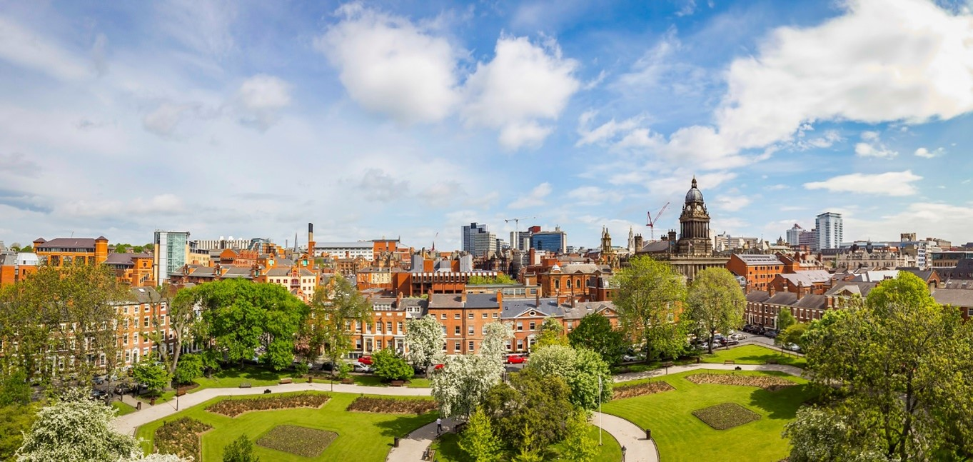
By answering this call, you are applying to the visit to Leeds in May 2022. Be aware that five visits in total will be organised in 2022, you can find the calendar below. The number of visits each representative can attend is limited to two.

Place | Topic | Case studies in focus | Themes of the visit | Dates
Leeds, UK | Recovery and resilience through cultural heritage in a post-pandemic world | Leeds museums and galleries services: how the municipal service has made innovative use of digital media to maintain and develop contacts with communities, schools and social media audiences throughout the pandemic, and how this has provided a foundation for more recent work to support recovery. | - Leeds Museums and Galleries (LMG) as a museum service run by Leeds City Council. The service manages nine sites which include heritage sites, museums, country house estates and a flagship art gallery.  - Resilience: Adaptation of cultural heritage institutions to the ‘new normal’ by delivering a range of activities and support to different audiences  - Digital engagement with schools and communities: curriculum planning and recovery curriculums, and podcasting. | 24-26 May 2022
Helsinki, Finland | Cultural heritage for local sustainable development  Governance and financing new roles for local and regional authorities | City Puzzle - towards a sustainable model of reusing old premises for cultural uses: the example of Kaapeli (the Cable Factory). The city of Helsinki and the real-estate company Kiinteistö Oy Kaapelitalo (Kaapeli) have been cooperating for 30 years to manage the former Cable Factory. The legal form of the company and full ownership of the premises led to a long-term sustainable operational model guaranteeing qualitative cultural activities. | - Sustainable and adaptive re-use of (industrial) heritage buildings for artistic uses  - Cooperation model between municipal departments: culture, city museums, housing and environment  - Governance models for transformed cultural heritage sites  - Helsinki City strategic framework for cultural heritage; Helsinki’s Real estate strategy; Culture and Art Vision 2030. | 13-15 June 2022
Krakow, Poland | Cultural heritage for local sustainable development | Sustainable cultural heritage development in practice: Krakow is developing several initiatives through its municipal culture service and its Municipal Greenspace Authority, capitalising on the city’s natural and cultural heritage and landscapes. | - Pocket parks in Krakow: The pocket parks programme aims at creating small, friendly green areas to create urban bonds with natural spaces. These intimate green areas are located in local neighbourhoods’ forgotten spaces, revealing a sometimes-forgotten cultural heritage.  - Symbiosis ecological education centre: located in a historical building located in a park, redeveloped in an environmentally friendly way, the centre offers exhibitions and workshops to residents around nature, ecology and sustainable development  - Villa Decius Institute for Culture (IKWD), a municipal cultural institution offering among other residences for artists, uses cultural heritage and culture for benefit of communities.  - Solutions developed by the Krakow cultural sector in response to the dynamic change in operating conditions caused by the pandemic | 31 August-2 September 2022
Cantabria region, Spain | Governance and financing new roles for local and regional authorities | Domus Dei to Domus Populi: the transformation of a religious building (Domus Dei) into an inclusive centre (Domus Populi) to facilitate community encounters and to welcome tourists and pilgrims. Read more. | - Rural development and territorial cohesion of the region via various cultural heritage initiatives and projects  - Use of European funds and projects for regional cultural heritage initiatives | End of September 2022 TBC
Zaragoza, Spain | Governance and financing new roles for local and regional authorities | The door breakers project: a project for the participation of young people in municipal museums organised by the Culture Service and the Youth Service of the Zaragoza City Council. The project proposes young people become the protagonists of the Museums and generate cultural and artistic projects in them. | - Cultural heritage’s universal accessibility: the role of museums: example of the project Between the Lights implemented in the Gargallo Museum  - Participation and social outreach to dynamize local museums and generate an atmosphere of continuous creativity  - The role of local museums towards young audiences: participation, creation, innovation | 26-28 October 2022

Your city/region
Name of the city/region or organisation:
Population or size:
Specific area of interest:
☐ | Recovery and resilience through cultural heritage in a post pandemic world
☐ | Cultural heritage for sustainable development
☐ | Governance and financing: new roles for local and regional authorities

Yourself
Name and surname:
Email address
Phone number
Your organisation (city, region, heritage stakeholders)
Position in the organisation:
Description of expertise and political responsibilities (if applicable) regarding culture and beyond

Your participation in the visit
Please describe the situation in your city/region and the challenges your city/region is facing (Please, elaborate, max. 300 words)
How do you think your participation in this peer-learning visit can be useful to help tackle your local issues at home (please, elaborate, max. 300 words)?
What do you expect from your participation in the peer-learning visit for your city/region? What are the desired outcomes and results? (Please, elaborate, max. 300 words).
What can you bring to the visit, both in terms of concrete policies and projects from your city/region and personal experience? (Please, elaborate, max. 300 words).
Please prepare max. three questions you have for the host city/region. This will help us refine the agenda of the peer learning visit.

Additional information
☐I acknowledge that I meet all regulations in place to enter and stay in the UK and I understand that the Cultural Heritage in Action cannot guarantee reimbursement of my costs shall this situation change. Information about the sanitary situation and conditions to enter the UK can be found here.
How did you find out about this call?
Would you like to receive future Cultural Heritage in Action electronic newsletters?
☐ | Yes
☐ | No
General Data Protection Regulation: please find all useful information here.

Please send this completed questionnaire to culturalheritageinaction@eurocities.eu
before 25 March 2022.
We will come back to you when we receive your contribution.
Any question? Contact us culturalheritageinaction@eurocities.eu

